Year 9 Biological Sciences Quiz 2:

Chemical Control & Coordination of Body Systems

Name: _______________________ Date: ________

Mark ____ / 69

|  |  |  |  |  |
| --- | --- | --- | --- | --- |
| Question |  |  |  |  |
| 1 | A | B | C | D |
| 2 | A | B | C | D |
| 3 | A | B | C | D |
| 4 | A | B | C | D |
| 5 | A | B | C | D |
| 6 | A | B | C | D |
| 7 | A | B | C | D |
| 8 | A | B | C | D |
| 9 | A | B | C | D |
| 10 | A | B | C | D |
| 11 | A | B | C | D |
| 12 | A | B | C | D |
| 13 | A | B | C | D |
| 14 | A | B | C | D |
| 15 | A | B | C | D |
| 16 | A | B | C | D |
| 17 | A | B | C | D |
| 18 | A | B | C | D |
| 19 | A | B | C | D |
| 20 | A | B | C | D |

1. MULTIPLE CHOICE --- 20 marks
2. 1. The diagram illustrates the body’s response to a sudden rise in blood glucose level (BGL). Identifythe INCORRECTstatement.
3. 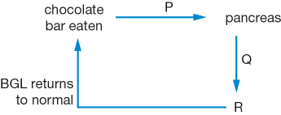
4. R represents the liver.
5. P represents a rise in blood glucose level.
6. Q represents a rise in insulin levels in the blood.
7. Glucagon is produced at R to reduce the blood glucose level.
8. 2. Select the combination that reflects the effect on urine production of drinking large amounts of water on a cool day.
9. increased volume, reduced concentration
10. increased volume, increased concentration
11. reduced volume, reduced concentration
12. reduced volume, increased concentration
13. 3. . People with the disease diabetes are either not able to produce insulin or their tissues are not able to respond to it.
14. Look at the graph below showing the changes in blood glucose levels of two students who have drunk the same volume of a glucose-rich soft drink.
15. 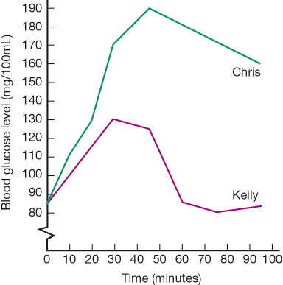
16. Which of the following statements is LEAST likelyto be true.
17. Kelly has greater control over blood sugar levels than Chris.
18. Chris is more likely to be a diabetic than Kelly.
19. It was 30 minutes before Kelly started to produce any insulin.
20. The blood glucose level in Chris’s blood will continue to decrease at a steady level.
21. 4. Describe the relationship between the pituitary gland and the hypothalamus.
22. The pituitary is called the ‘master gland’. The hypothalamus responds to messages from the pituitary gland.
23. The hypothalamus secretes hormones that act on the pituitary gland.
24. The hypothalamus is part of the brain. The pituitary gland is located in front of the trachea in the neck.
25. The hypothalamus constantly checks the conditions within the organs and systems of your body. The pituitary gland checks the activity of the brain.
26. 5. The following list is of reactions of the body to a reduction in body temperature.
27. Identify the CORRECT reaction caused by the endocrine system.
28. shivering to increase activity of muscle cells
29. narrowing of the blood vessels near the surface of the skin
30. increased rate of metabolism caused by thyroxine
31. reduced blood flow to the fingers, toes, nose and ears
32. 6. If you are in a frightening situation your adrenal glands produce epinephrine (commonly called adrenalin).
33. Which is the INCORRECTeffect of this hormone on your body.
34. increased heart rate to pump more blood round your body
35. expanded blood vessels allowing blood to flow smoothly
36. opened up air passages allowing more oxygen to be taken into the body
37. inhibited insulin secretion causing glucose to remain in the blood

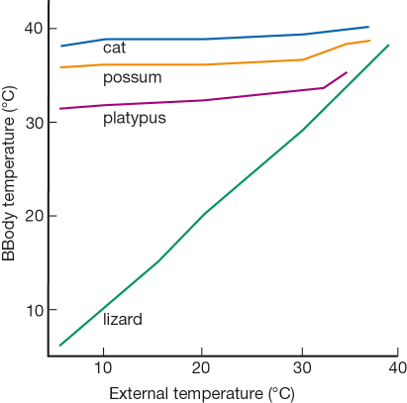

7. Which organisms’ body temperature is **LEAST** likely to be controlled by homeostasis.

1. Cat
2. Possum
3. Platypus
4. Lizard

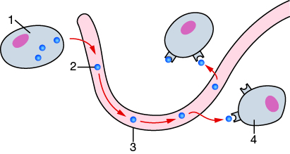

8.Look at the diagram of a target cell and hormone receptors

Identify the CORRECT statement about parts of the diagram labelled 1, 2, 3 and 4 and their function.

1. (1) is a target cell and it produces the hormone represented by (2).
2. (4) is a target cell for the hormone represented by (2).
3. (1) is a cell in an endocrine gland and 3 is the duct that carries the hormone (2) to the target cells (4).
4. (3) is a blood vessel carrying the hormone (2) from the target cell (1) to other body cells (4).
5. 9. The hypothalamus monitors the volume of blood passing through it or the concentration of water in the blood.
6. When there is less water than required, a message from the hypothalamus to the pituitary gland causes it to release antidiuretic hormone (ADH).
7. ADH causes the kidneys to reabsorb water directly from the renal tubules of the kidney.

Use this information to deduce what is represented by the numbers 1, 2 and 3 in the diagram and in that order.

1. 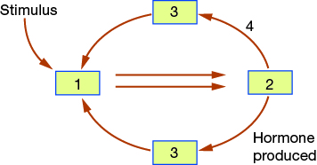
2. hypothalamus – pituitary gland – kidney
3. hypothalamus – kidney – antidiuretic hormone
4. pituitary gland – hypothalamus – kidney
5. pituitary gland – antidiuretic hormone – kidney
6. 10. Use the information in question 9 above. If the pathway that was followed used arrow 4, which statement is most likely to be CORRECT:.
7. The stimulus was low water content in the blood, and hormones were released that caused the kidneys to reabsorb water from the tubules.
8. The stimulus was low water content in the blood, and hormones were not released and this caused the kidneys to reabsorb water from the tubules.
9. The stimulus was high water content in the blood, and hormones were released that caused the kidneys to reabsorb water from the tubules.
10. The stimulus was high water in the blood, and hormones were not released and this caused the kidneys to reabsorb water from the tubules.

11. The endocrine system:

1. delivers messages more slowly than the nervous system
2. has one central location to control all activities.
3. passes messages along neurons.
4. relies on electrical impulses to transfer messages.

12. Read the graphs

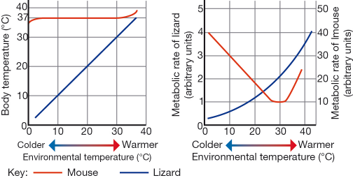

1. Identify the correct comparison between the mouse and the lizard.
2. As the external temperature increases, the rate of metabolism for the mouse decreases and for the lizard increases.
3. The rate of metabolism in the mouse is always greater than the rate of metabolism in the lizard.
4. The body temperature of both the mouse and the lizard are affected to the same extent by the external temperature
5. As the body temperature of the lizard increases, the rate of metabolism also increases.
6. 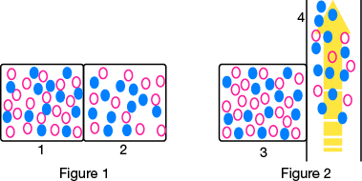13. Figure 1 represent two cells sitting side by side.
7. Figure 2 is a cell next to a blood capillary.
8. Use your ideas of diffusion to deduce which of the following events is most likely to occur.
9. Both andrepresent dissolved substances that can move freely through cell membranes.
10. The concentration of will eventually be the same in cell 3 and in capillary 4.
11. The substance will move from cell 2 to cell 1.
12. Substance will move more rapidly from cell 1 to cell 2 than substance .
13. Substance and substance will both move at the same rate from cell 3 to capillary 4.

14. Which of the following is NOT usually controlled by hormones?

1. Rate of breathing.
2. Sexual development.
3. Water balance.
4. Cell growth and development.

15. The approximate body temperature and blood pH of a healthy human are

1. 37°C and pH7.38.
2. 37°C and pH 5.38.
3. 33°C and pH 7.38.
4. 33°C and pH 5.38.

16. Which of the following glands provides the most direct link between the endocrine and nervous systems?

1. Pituitary B. Thyroid
2. Pancreas D. Ovary
3. 17. When the level of carbon dioxide CO2 in your blood FALLS, the usual response of your body is to:

A decrease breathing rate

B increase breathing rate

C produce the hormone oestrogen

D produce the hormone insulin

1. 18. Which of the following is usually largely controlled by the ENDOCRINE SYSTEM?
2. A breathing B heartbeat

C tasting D water balance

1. 19. The disease *diabetes mellitus* is most often associated with which hormone?
2. A insulin B human growth hormone

C thyroxin D testosterone

1. 20. The diagram below shows a sketch of the human endocrine system.
2. 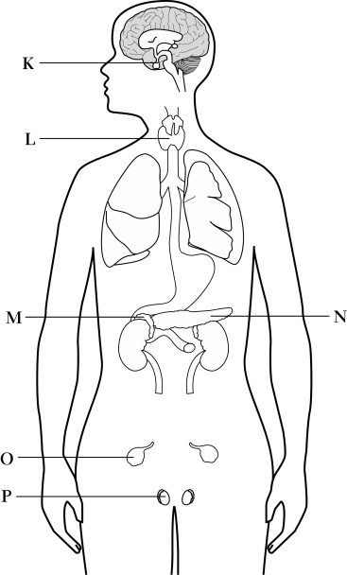
3. Which of the following correctly matches a gland (as labelled on the diagram) with the function controlled by a hormone it releases?

A Gland L releases a hormone that controls female sexual development.

B Gland O releases a hormone that controls blood glucose levels.

C Gland M releases a hormone that controls the rate of chemical reactions   
in cells.

D Gland K releases a hormone that controls water balance

|  |  |
| --- | --- |
|  | SHORT ANSWER SECTION : 49 marks |
|  | a What is homeostasis?  ______________________________________________________________________________________________________________________________________________________________________________________________________ (2)   1. b Name twosubstances whose levels are homeostatically controlled  * ______________________________________ * ______________________________________ (2) |
|  | 1. After EXERCISE your body temperature increases… 2. State: 3. a one area where receptors  that detected this increase would be located 4. __________________________________________ 5. b the coordinating centre that would receive messages 6. __________________________________________ 7. c one organ or gland that might act as an effector 8. __________________________________________ 9. d one response you might detect   __________________________________________  (4) |
|  | Match the number of each stimulus to a receptor.  STIMULUS RECEPTORS   1. water levels in the blood testicles produce   2. glucose levels in the blood adrenal glands produce epinephrine  3. male puberty hypothalamus signals to blood vessels  4. heat pancreas which increases insulin  5. stressful situation osmo-receptors in large arteries  (5) |
|  | LABEL Model of Enzyme Action  Labels include: Substrate Enzyme- Substrate Complex  Smaller particles Enzyme    (4)  All the reactions in your body are helped along by E________________.They are organic C__________________ - substances that speed up the reaction Rate of chemical processes in the cells.  How many enzymes in human body? ____________  Is each one specific to one particular chemical reaction ? __________  Each enzyme has a particular S_____________________ that allows it to attach to a specific M________________ that is going to be changed by the chemical R________________ = the reactant molecule. In a reaction the E___________ and the Substrate join together and undergo a chemical breakdown process. The Enzyme is not changed in this process.  Enzymes can increase the S______________________ of a Chemical Reaction by up to (select the correct response) 8 times 1 10 times 10 billion times … faster.  (10) |
|  | Draw a line to match the food to its smallest / most simple chemical substances  **Food Simplest chemical components**  Carbohydrates Fatty Acids & Glycerol  Proteins Amino Acids  Lipids Simple Sugars & Glucose  (3) |
|  | **Changes to Heart Rate**  If you are frightened by the crash of a burglar breaking into your house  Number 1 -5 in boxes below the correct order of events which  trigger the “Fight or Flight” Response Mechanism  Heart Rate increases  Medulla Sends message to the Sino Atrial Node  Adrenal glands release hormone adrenaline to receptors in body  Blood Flow is increased  Muscles are supplied with extra Oxygenated Blood (5) |
|  | The air you breathe enters your r_______________ system through your nose and mouth. It passes down the trachea, bronchi and then smaller bronchioles it ends up in the a____________(tiny air sacs)  Oxygen dissolves in the m__________ s_____________ and moves by d_______________ across the space to the bloodstream.  In the blood OXYGEN combines with haemoglobin on the R________B____________C________ . The flow of blood carries oxygen away so C________________ in alveolus and blood never become E_________. O2 continues to move through the blood. (8) |
|  | Match each hormone to the functions it controls  HORMONE EFFECTS/CONTROL  1 testosterone rate of chemical reactions in cells  2 thyroxin female sexual development  3 insulin readiness for flight or fight  4 antidiuretic hormone (ADH) water balance  5 adrenalin blood glucose levels  6 oestrogen male sexual development  (6) |

End of Test --- check all answers